Set 19: Survey Responses Analysis
Department | AIDS
Course Code / Course Name | DSA0602/ Data Handling and Visualization
Experiment | Data Visualization using R
Name | YASHIKA.R
Register Number | 192525102
Date | 13/10/2026
Day | Tuesday

1. Grouped bar chart — Question 1
Aim: To visualize the frequency of answers to Question 1.
Algorithm:
- Create a data frame containing survey IDs and responses.
- Count the occurrences of each answer.
- Draw a bar chart showing the response frequencies.
- Add a title and axis labels.
Code:
if (!requireNamespace("ggplot2", quietly = TRUE))
install.packages("ggplot2", type = "binary")
library(ggplot2)

survey <- data.frame(
ID = 1:3,
Q1 = c("A", "B", "C"),
Q2 = c("B", "A", "A"),
Q3 = c("C", "D", "B")
)

q1_data <- as.data.frame(table(survey$Q1))
names(q1_data) <- c("Answer", "Frequency")

ggplot(q1_data, aes(x = Answer, y = Frequency, fill = Answer)) +
geom_col() +
labs(title = "Question 1 Response Distribution",
x = "Answer", y = "Frequency") +
theme_minimal() +
theme(legend.position = "none")
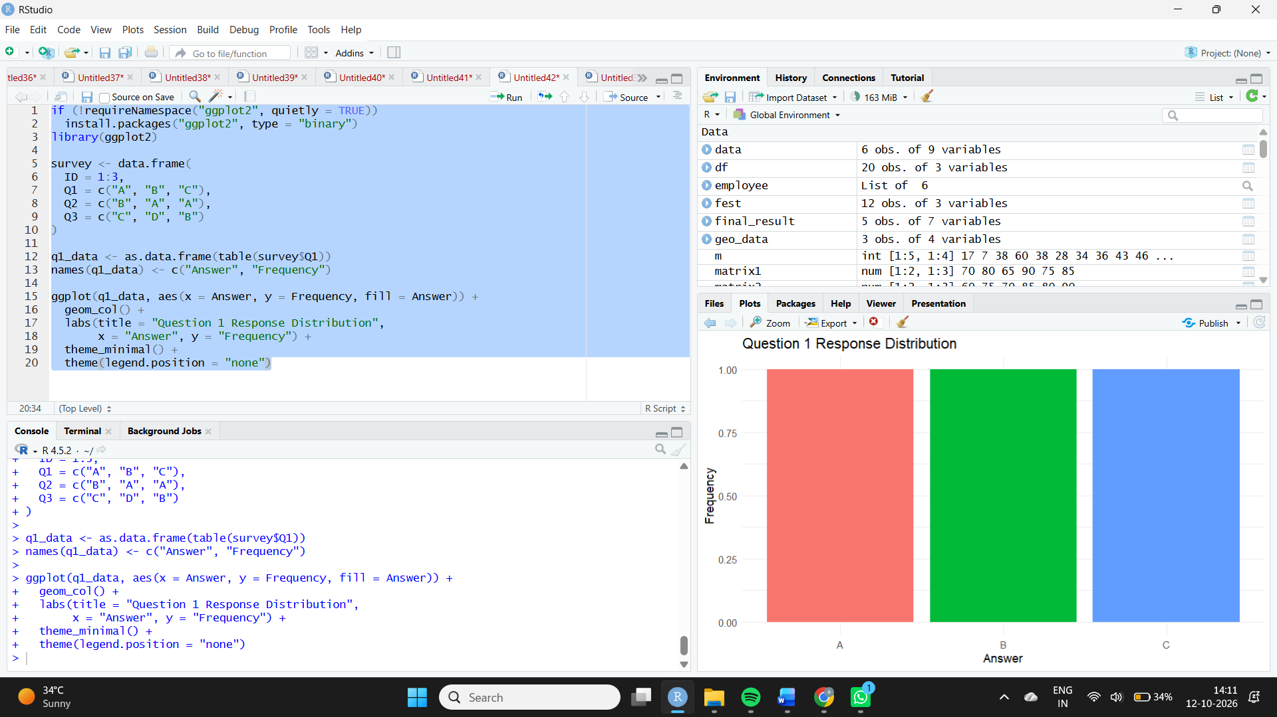
Observation: Answers A, B, and C each occur once. Therefore, all three answers have equal frequency.
2. Stacked bar chart — Overall survey responses
Aim: To represent the distribution of responses across all three survey questions.
Algorithm:
- Convert the three question columns into a long-format dataset.
- Group responses by question and answer.
- Draw a stacked bar chart with different colours for answers.
- Add a legend and labels.
Code:
library(ggplot2)

survey_long <- data.frame(
Question = rep(c("Question 1", "Question 2", "Question 3"),
each = 3),
Answer = c(survey$Q1, survey$Q2, survey$Q3)
)

ggplot(survey_long, aes(x = Question, fill = Answer)) +
geom_bar() +
labs(title = "Overall Distribution of Survey Responses",
x = "Survey Question", y = "Number of Responses",
fill = "Answer") +
theme_minimal()
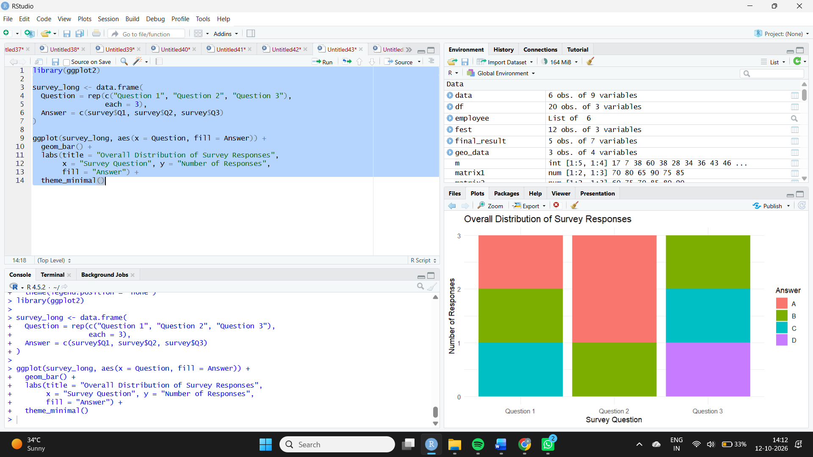
Observation: Each question has three responses. Across all nine responses, A appears three times, B three times, C twice, and D once.
3. Survey response table
Aim: To display the responses given by each survey participant.
Algorithm:
- Create a data frame of survey IDs and answers.
- Assign meaningful column names.
- Display the records.
Code:
print(survey)
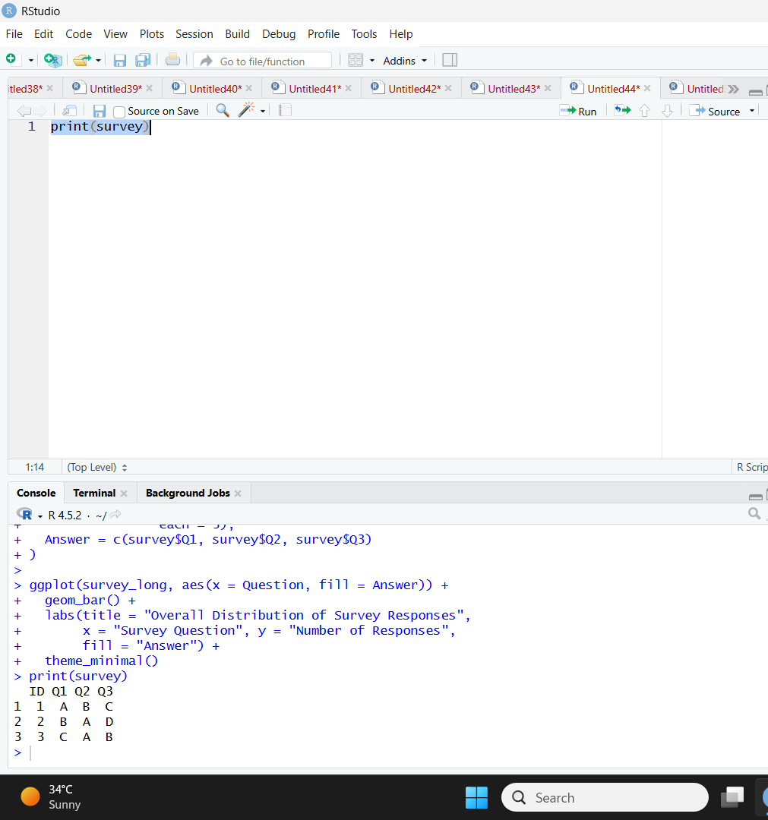
Observation: The table displays the answers for all three questions for each survey ID.
4. Tableau dashboard
Aim: To combine the Question 1 bar chart, overall stacked bar chart, and survey response table into an interactive dashboard.
Algorithm:
- Import the survey dataset into Tableau.
- Create a Question 1 response frequency chart.
- Pivot Question 1, Question 2, and Question 3 into a long-format structure.
- Create the stacked bar chart.
- Create a survey response table.
- Combine the worksheets and configure filters.
Procedure in Tableau:
- Connect to the survey dataset.
- For the first chart, place Question 1 on Columns and COUNT of Survey ID on Rows.
- For the second chart, pivot the three question columns into Question and Answer fields, then place Question on Columns, COUNT of Survey ID on Rows, and Answer on Color.
- Create a table with Survey ID, Question 1, Question 2, and Question 3.
- Add all worksheets to a dashboard.
- Add a Survey ID filter and enable chart selections to filter other views.
Observation: The dashboard enables users to compare answer frequencies, explore response patterns across questions, and view individual survey records.

